Narrative Interface User Guide

Prepared by Elementary Engineers:

Olga Sheehan, Sara Hakkoum,

Eric Holm, Ethan Fiero

Instructor: Dr. Jung

Framingham State University

2016

## Abstract

The “Fraction Worksheet Creator” (FWC) is an off-line worksheet generation tool designed by Elementary Engineers to help elementary school teachers to create a lot of exercises for students to study and practice fractions. The fractions worksheets are randomly created and never repeated so the teachers have an endless supply of quality fractions worksheets to use in the classroom or at home.

The purpose of this document is to give a detailed paper prototyping of the requirements for the “Fraction Worksheet Creator” (FWC) software for user. It will illustrate the prototype drawn in a mockup creation and prototyping tool and demonstrates the features of the software. It will also explain interface with all functionalities on the requirement documentation.

This document is primarily intended to be proposed to a customer and the board of directors for their approval and a reference for developing the first version of the system for the development team.

Table of Contents

Abstract 1

Admin Software Registration 1

Login 2

User forgot the password 2

Administrator password reset 3

Admin Home 3

Admin – Reset passwords 4

Admin - Teacher Profile 4

Teacher registration 5

Teacher – force reset 5

Teacher Home 6

Teacher – Worksheet History 6

Teacher – Classes 7

Teacher – Adding a New Class 7

Teacher - Edit Class 7

Student registration 8

Teacher – Class roster 8

Teacher – Student profile 8

Teacher – Student worksheet history 9

Teacher – Student password reset 9

Student - Home 9

All users – Tutorials 10

Single tutorial 10

Student worksheet history 11

Help 11

Graphical Mockup 11

## Admin Software Registration

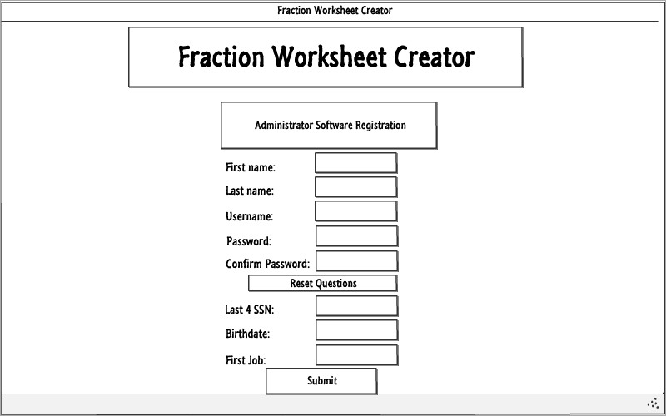

## Login

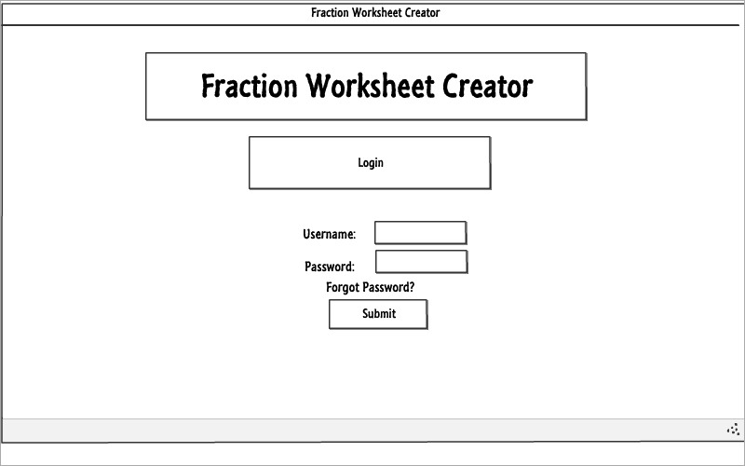

## User forgot the password

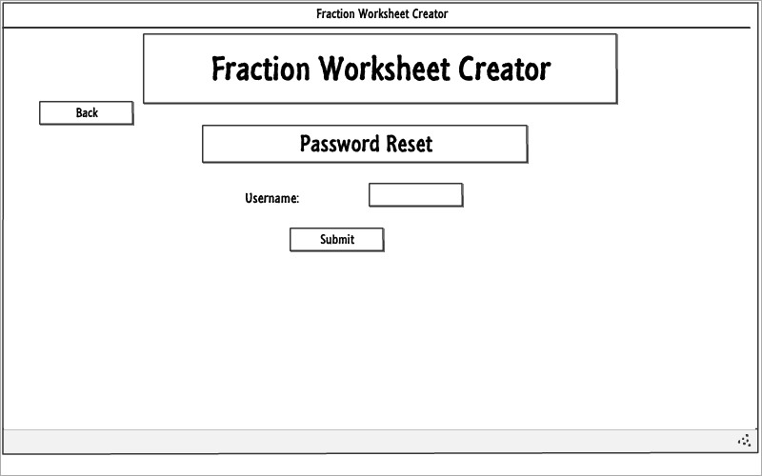

## Administrator password reset

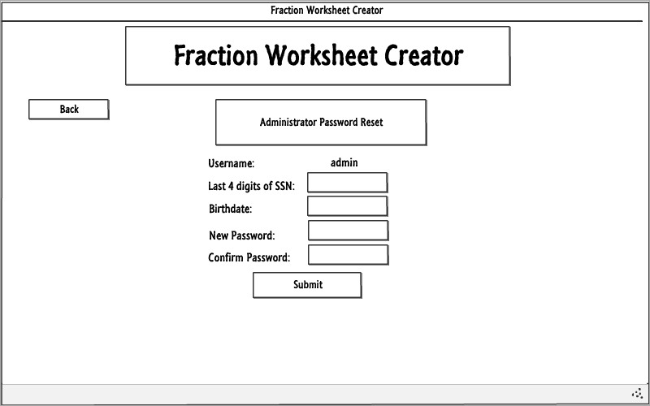

## Admin Home

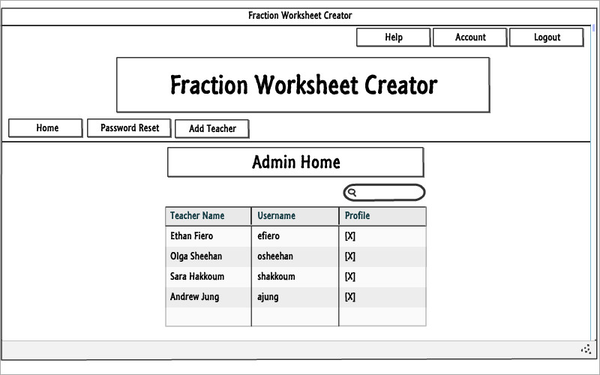

## Admin – Reset passwords

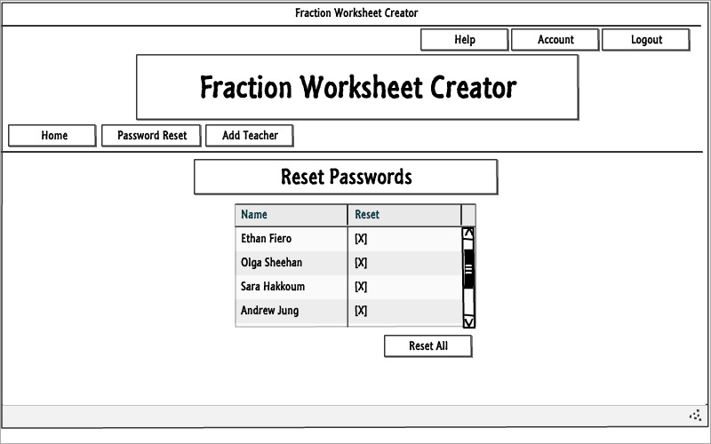

## Admin - Teacher Profile

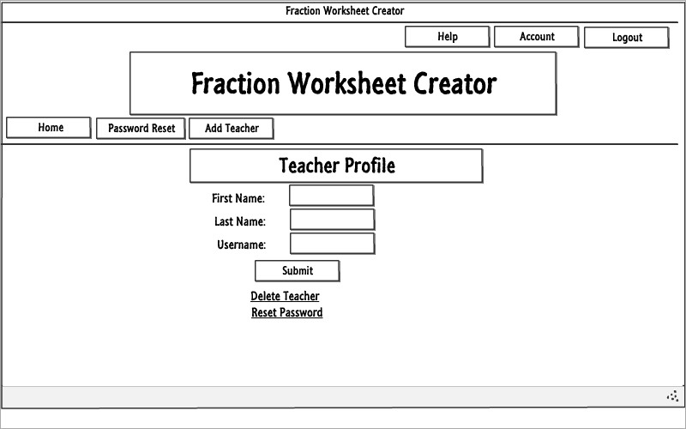

## Teacher registration

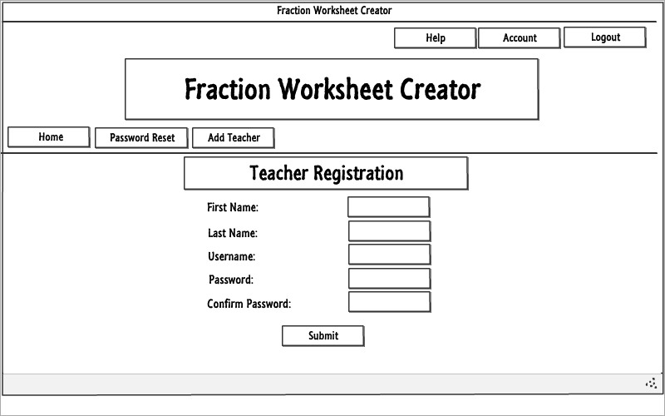

## Teacher – force reset

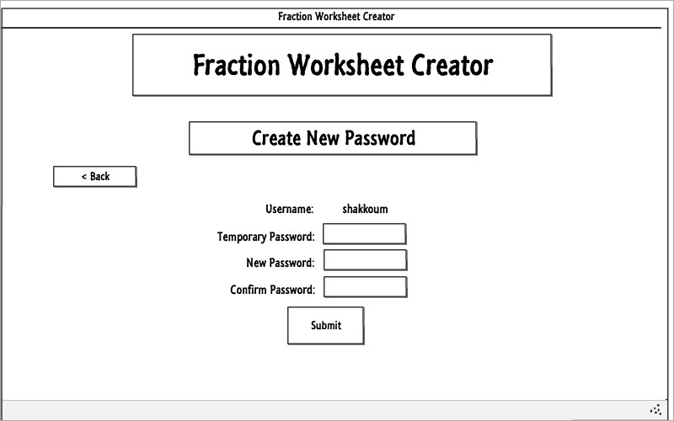

## Teacher Home

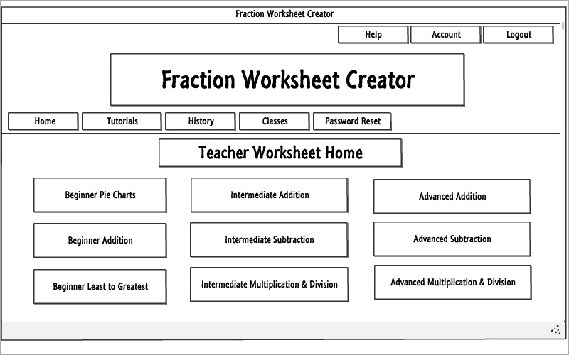

## Teacher – Worksheet History

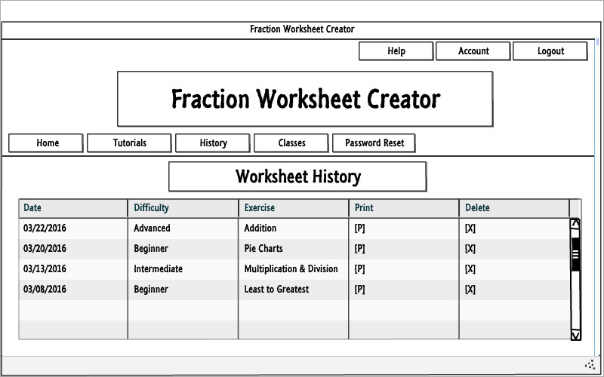

## Teacher – Classes

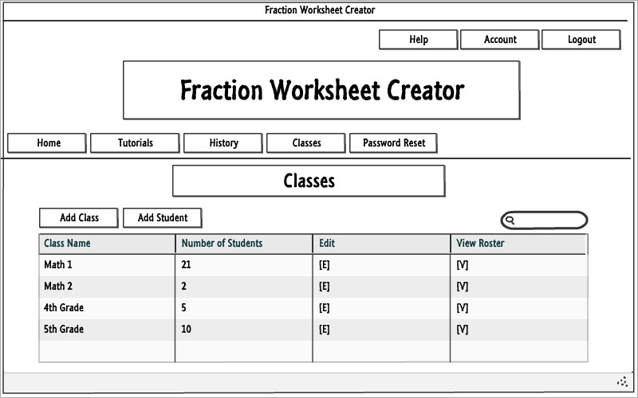

## Teacher – Adding a New Class

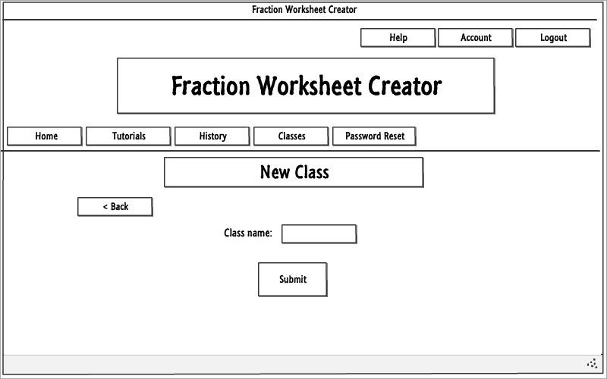

## Teacher - Edit Class

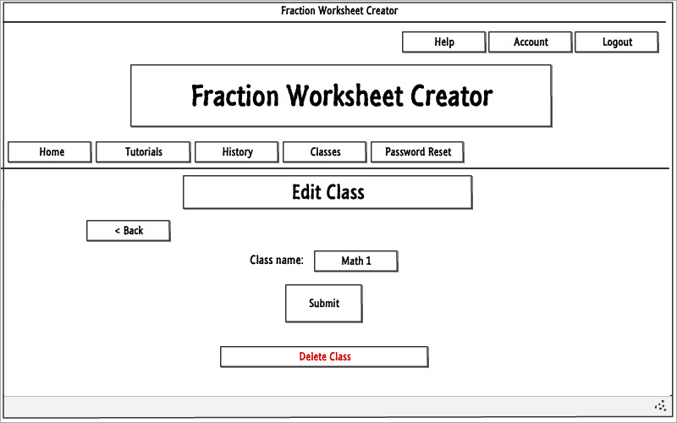

## Student registration

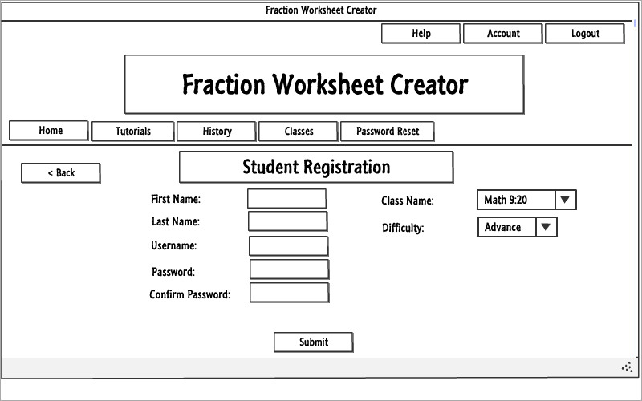

## Teacher – Class roster

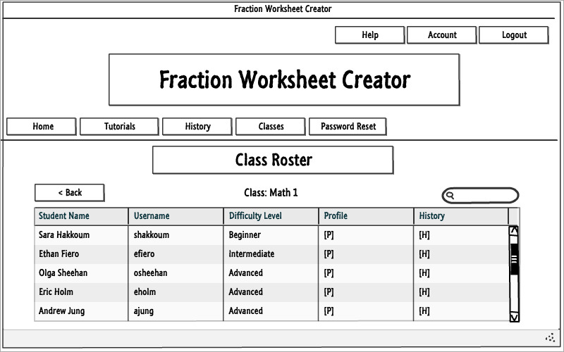

## Teacher – Student profile

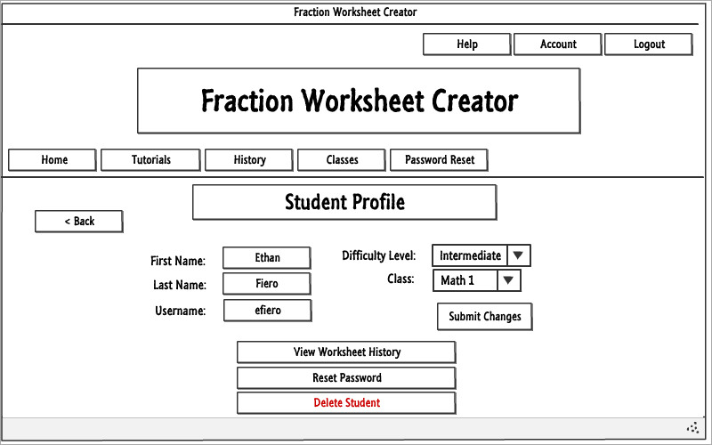

## Teacher – Student worksheet history

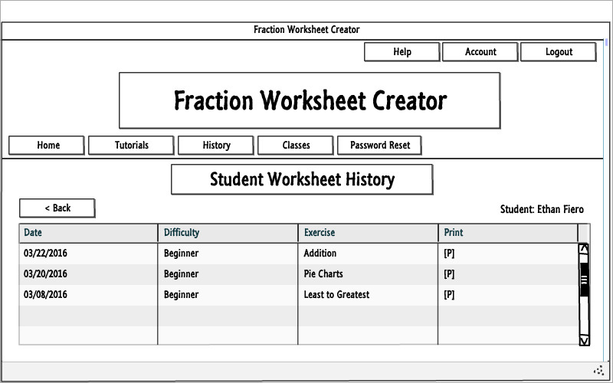

## Teacher – Student password reset

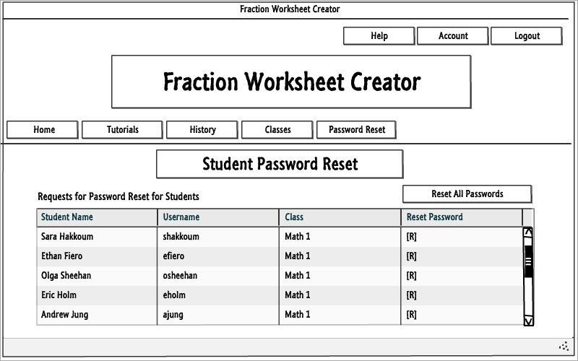

## Student - Home

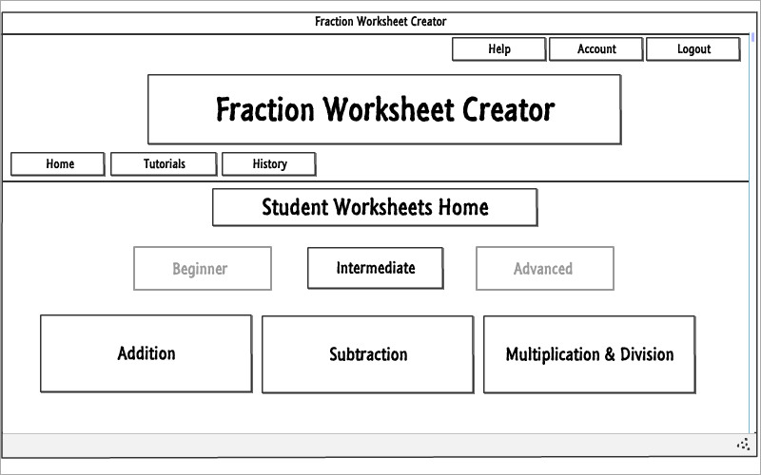

## All users – Tutorials

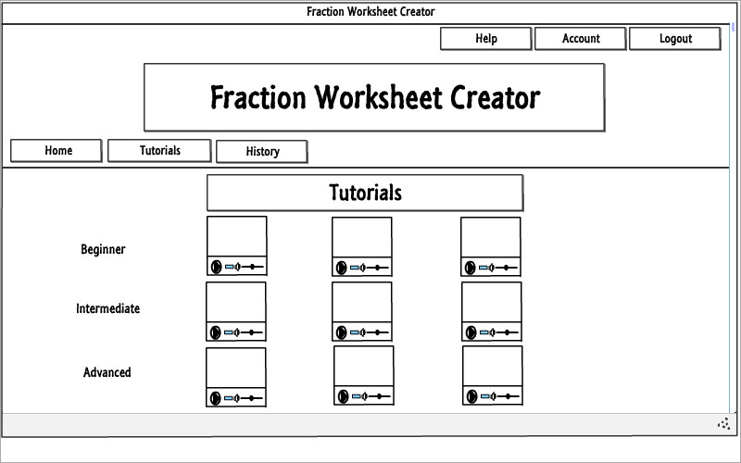

## Single tutorial

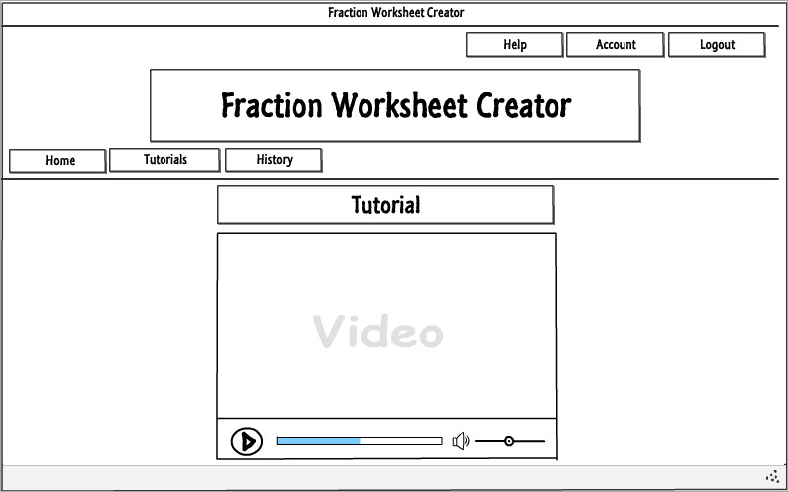

## Student worksheet history

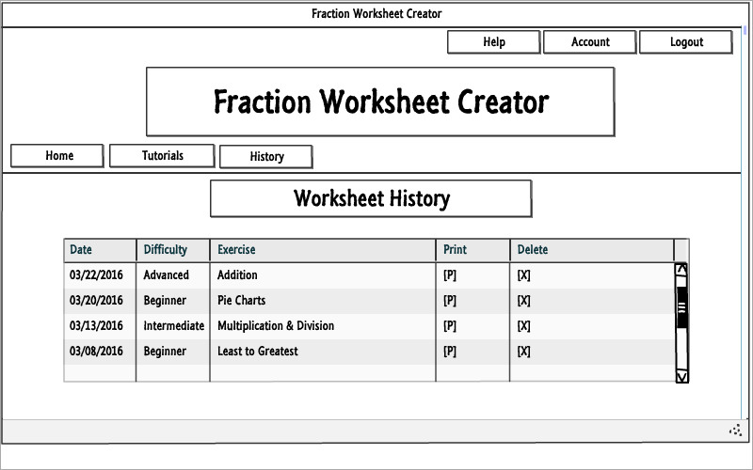

## Help

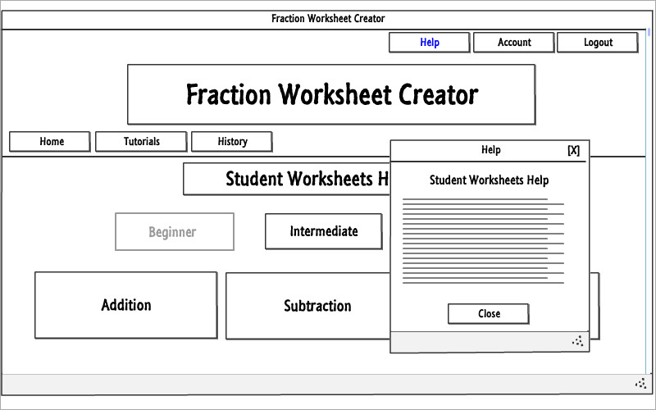

## Graphical Mockup

